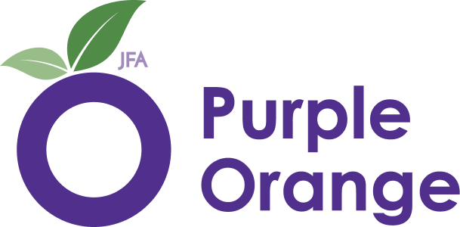


Sign up to have your say


Easy English

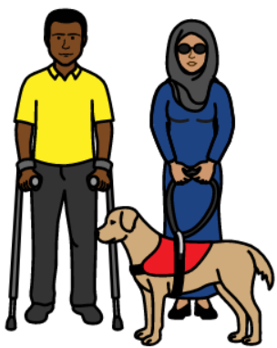
Do you live with a disability or are a supporter or loved one of a person with disability?
If yes, you can help us with our work.
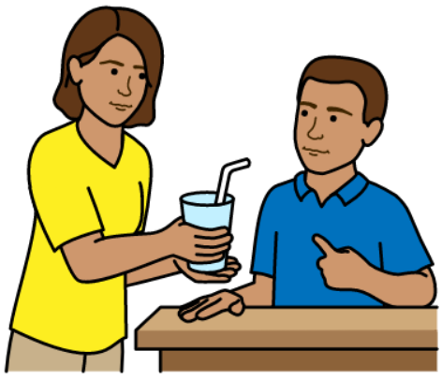
A supporter is anyone who helps the person with disability. They could be a support worker or carer.
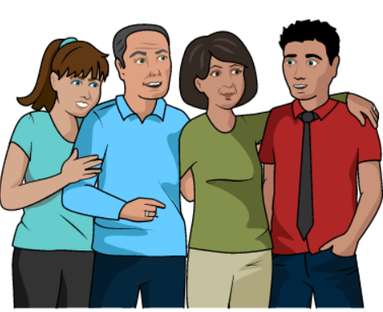
A loved one could be a
- family member
- friend
- partner.

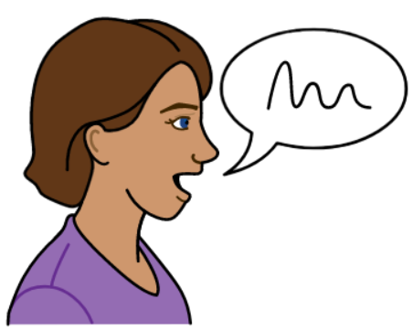
What you have to say is important to us.

We want to hear from
- people with disability
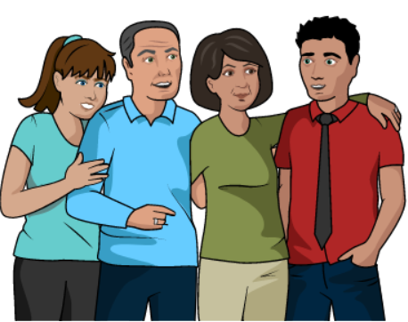
- family or loved ones of people with disability
- people who help like support workers.

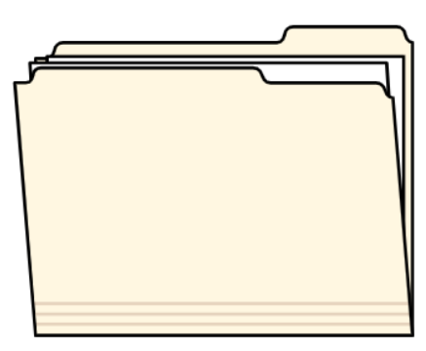
We make sure people with disability and their loved ones and supporters are part of our work like
- projects
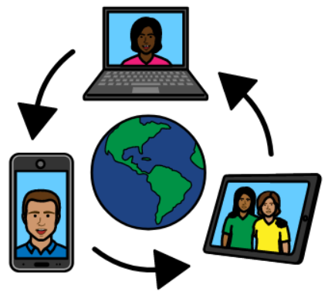
- research
- events
- media.

This could look like
- videos
- people telling stories
- sharing your thoughts and ideas.


We want to make a list of people who want to help us.
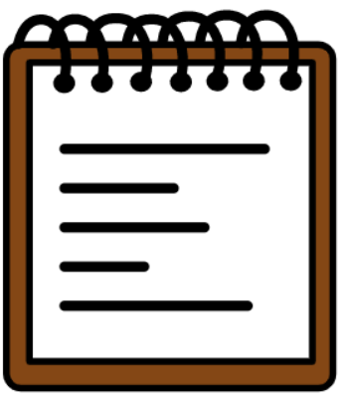


You might get gifts for doing certain things. This is called an honorarium.


We want to hear from different people like
- LGBTQIA+ people

- First Nations people
- people of different ages
- people who are from different countries.


Please fill out the form to help us with our work.
If you need help with filling out this form you can contact us.
Phone: 8373 8388
You could also ask a loved one or support person for help.


We will not share your information.

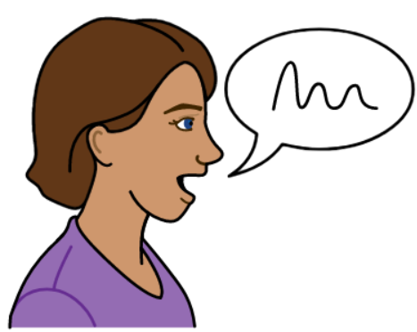
You can change your mind. Tell us and we will take your name off the list. You can: Email: media@juliafarr.org.au
Or
Phone: 8373 8388

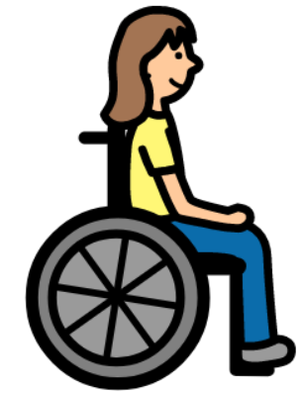
There are different sign-up forms for
- person with disability
and
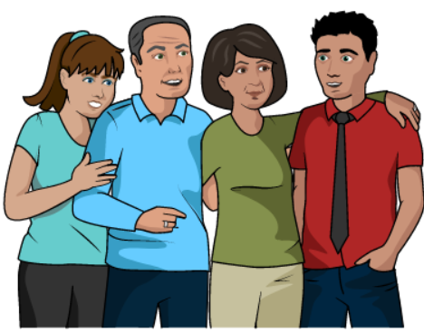
- loved ones or supporters of people with disability
Please choose the right sign-up form below.

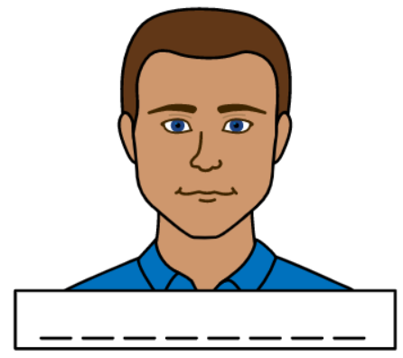
Sign up form to have your say
(for person with disability)
What is your first name?
__________________________________

What is your last name?
__________________________________


What is your phone number?
__________________________________


What is your email address?
__________________________________
How would you like us to contact you?
☐Email
☐Phone
☐Text message
☐Other____________________________
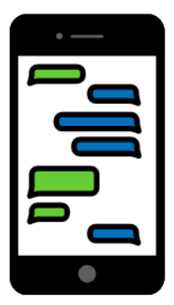
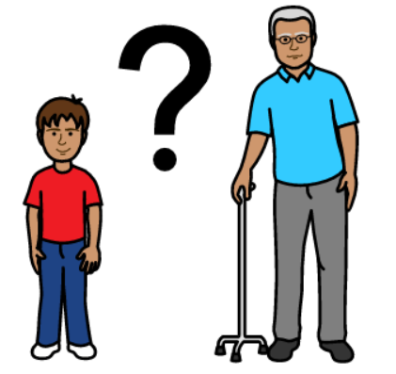
How old are you? ______

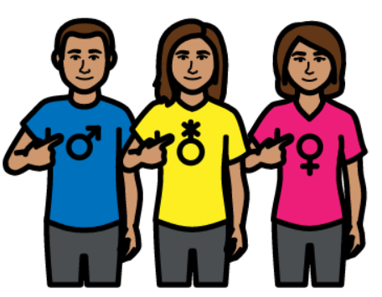
What is your gender?
☐Female
☐Male
☐Non-binary
☐I do not want to say
☐Other______________________

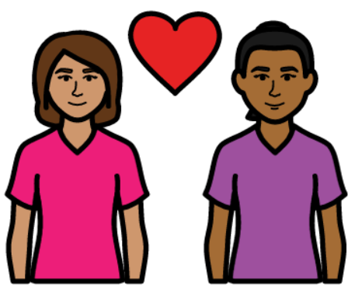
Are you part of the LGBTQIA+ (lesbian, gay, bisexual, transgender, queer, intersex and asexual people) community?
☐Yes
☐No
☐I do not want to say

Are you a person with a disability?
☐Yes
☐No
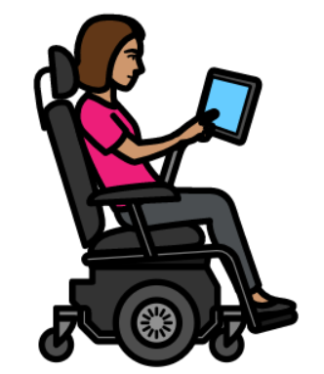
What is your disability or disabilities? (You do not have to say if you do not want to.)
☐Autistic
☐Deaf
☐Blind
☐Learning/intellectual disability
☐Mental illness
☐Psychiatric disability
☐Sensory disability
☐Other – please tell us more:
__________________________________
☐I do not want to say
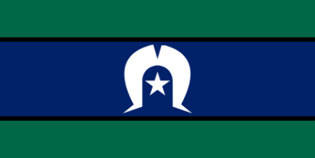
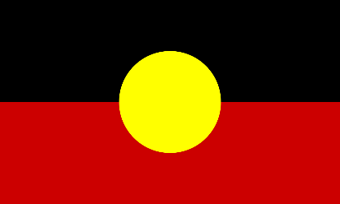
Are you of Aboriginal or Torres Strait Islander origin?
☐Yes, Aboriginal
☐Yes, Torres Strait Islander
☐No
☐I do not want to say

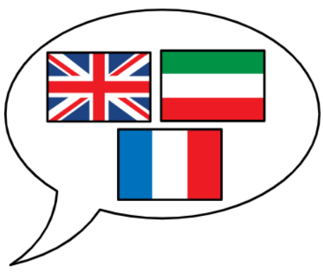

Do you speak another language besides English at home?
☐Yes
☐No
☐I do not want to say
If yes, what other language/s do you speak at home besides English? __________________________________

Are you from another country or culture?
☐Yes
☐No
☐I do not want to say
If yes, what country are you from? __________________________________
If yes, what is your culture? __________________________________

You can phone or email us if you
- have questions about this form
- want to give feedback about this form.
Phone: 8373 8388
Email: media@juliafarr.org.au
After you have filled out the form you can
Email it to us:
media@juliafarr.org.au

OR
Post it to us:
104 Greenhill Road, Unley SA 5061

Sign up form to have your say
(for loved ones or supporters of person with disability)
What is your first name?
__________________________________

What is your last name?
__________________________________

What is your phone number?
__________________________________

What is your email address?
__________________________________

How would you like us to contact you?
☐Email
☐Phone
☐Text message
☐Other____________________________
How old are you? ______

What is your gender?
☐Female
☐Male
☐Non-binary
☐I do not want to say
☐Other______________________

Are you part of the LGBTQIA+ (lesbian, gay, bisexual, transgender, queer, intersex and asexual people) community?
☐Yes
☐No
☐I do not want to say

What is your relationship to the person with disability you care for or support? (for example, family member, support worker, friend etc.)
______________________________________________________________________________________________________

Are you of Aboriginal or Torres Strait Islander origin?
☐Yes, Aboriginal
☐Yes, Torres Strait Islander
☐No
☐I do not want to say

Do you speak another language besides English at home?
☐Yes
☐No
☐I do not want to say
If yes, what other language/s do you speak at home besides English? __________________________________

Are you from another country or culture?
☐Yes
☐No
☐I do not want to say
If yes, what country are you from? __________________________________
If yes, what is your culture? __________________________________

You can phone or email us if you
- have questions about this form
- want to give feedback about this form.
Phone: 8373 8388
Email: media@juliafarr.org.au

After you have filled out the form you can
Email it to us:
media@juliafarr.org.au
OR
Post it to us:
104 Greenhill Road, Unley SA 5061

