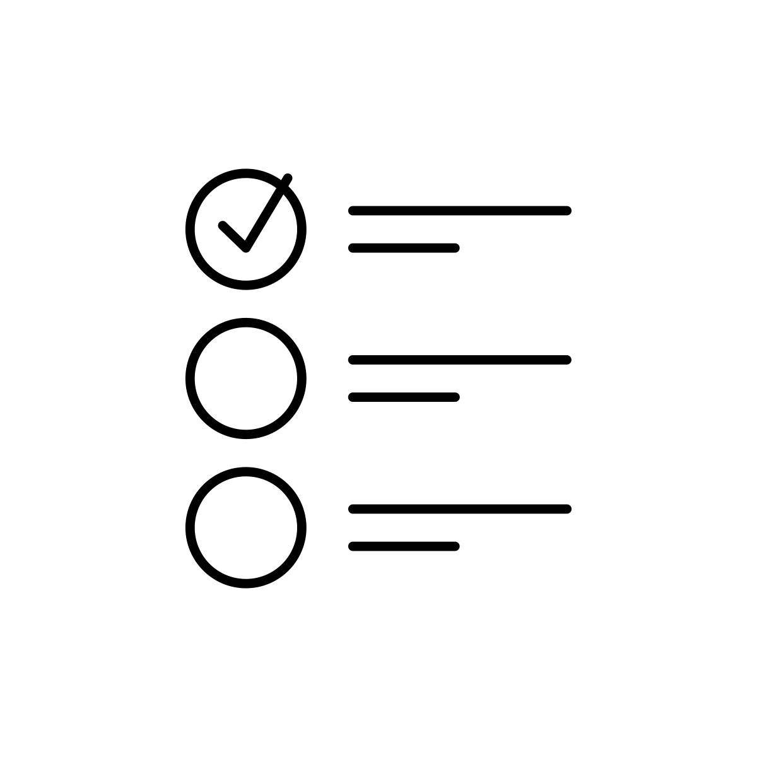
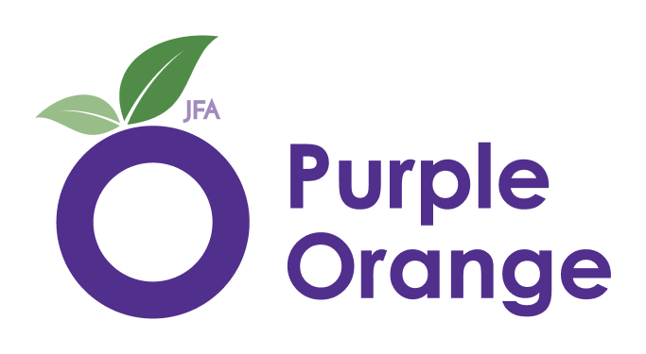

Our Plan.
2024 to 2027

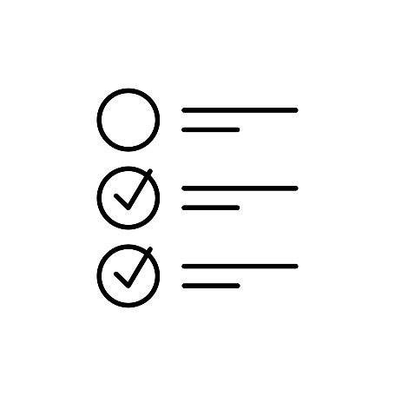
What Purple Orange does

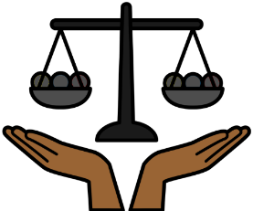
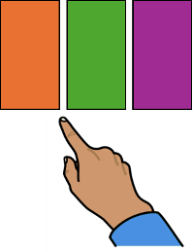
We make sure people with disability
- have rights
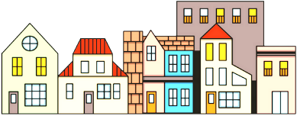
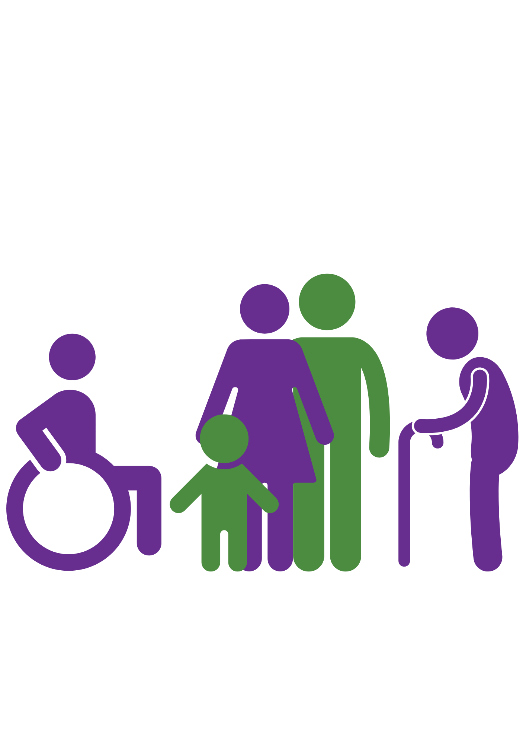
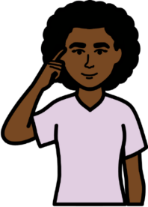
- can make their own choices
- are part of the community
- lean new things.

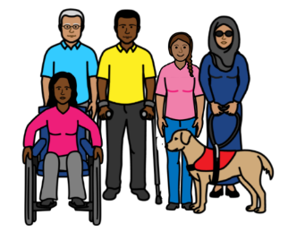
We do this by working with
- people with disability



- other disability organisations
- government.

What Purple Orange believes

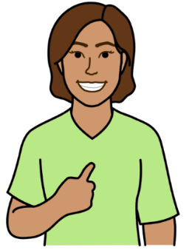

We think you should have things in your life.
Like you
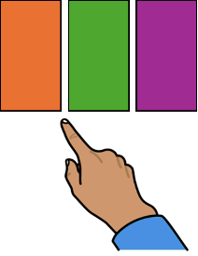
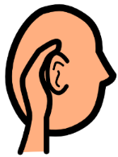
- are in charge of your life.
- have a good plan for the future
- can make your own choices
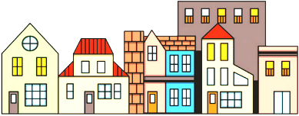
- are listened to
- are part of the community
- know how to do things.

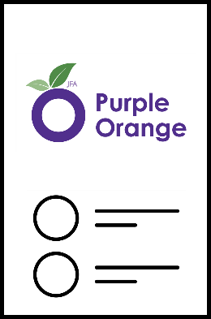
Our new plan

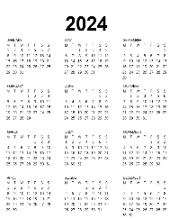
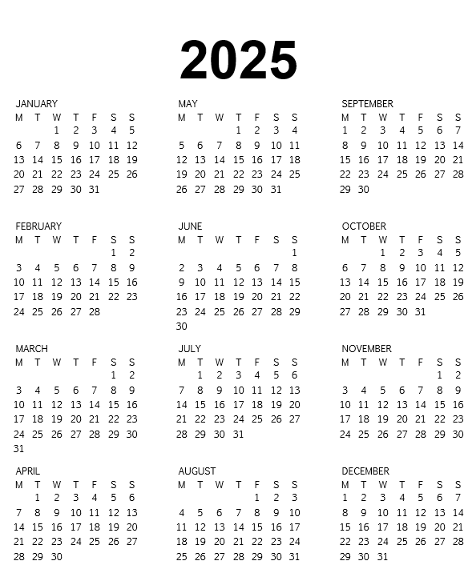
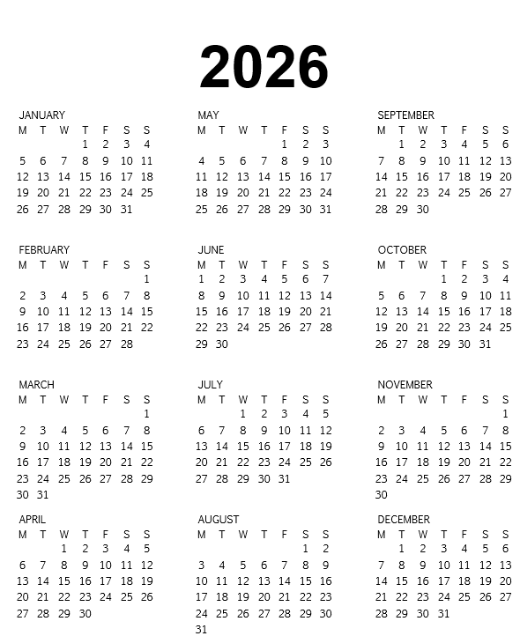
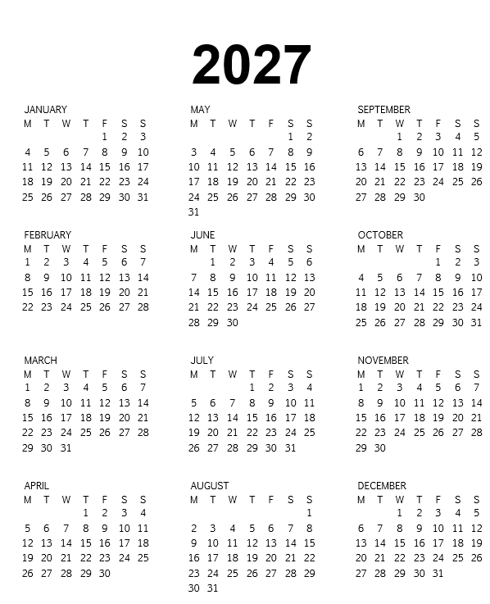
The plan is for 3 years.
The plan started in July 2024.
The plan ends in June 2027.

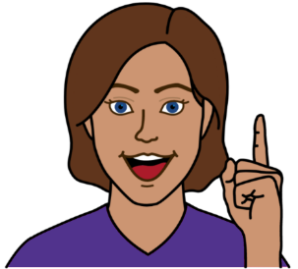
We have 5 big ideas. We call them focus areas
They are important things we must do.

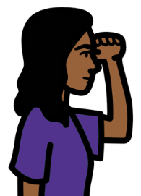
Our vision
This is what we want Purple Orange to be.
We will do this by 2027.

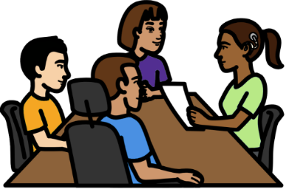
People with disability are part of everything we do.
We use co-design in our work.

We work in ways that are
- fair
- responsible
- respectful
- honest.

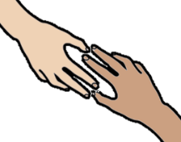
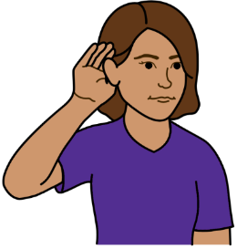
We are a strong partner in the disability community. Like we
- help people to be leaders.

- listen to people with disability.
- make things better. Like
  - systems
  - community.

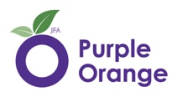
People and places use our work to learn about things. Like how to
- make systems better for people with disability
- include people with disability in the community
- give people with disability all their rights.

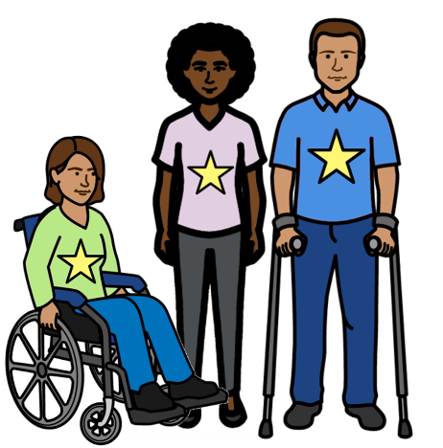
Focus area 1. Building Leadership
We want people with disability to be leaders.

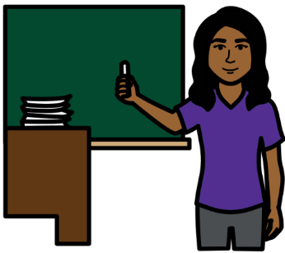
We will run workshops for people with disability.
This will help people learn how to be a leader.

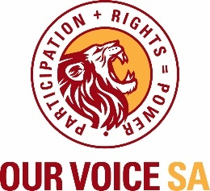
We will help group run peer networks. Like
- Our Voice SA
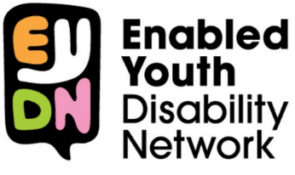
- Enabled Youth Disability Network



We will share information in ways that people can understand. Like
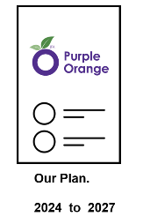

- Easy English. Like this report
- video
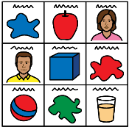

- pictures
- listen to it.

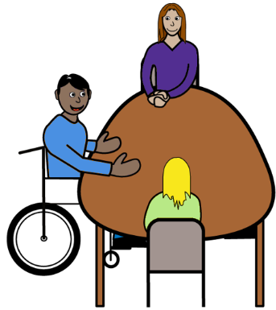

We will make things easy for people to be leaders. Like
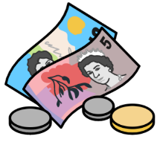
- make places for people with disability to be leaders
- give money to people to do training.

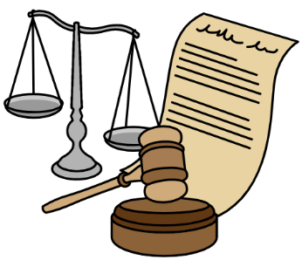
Focus area 2. Make systems better
We will make sure systems are better for
people with disability.

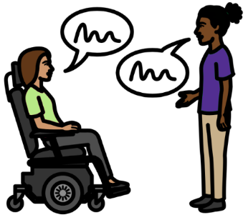
We will find out what different people think. We
- will ask questions
- will listen
- will learn.


We will use what we hear to plan our work.
We will talk about what people tell us.



We will find out
- what works now
- what needs to change

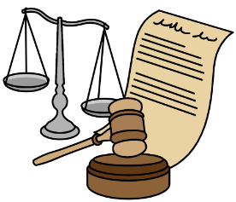

We will share our ideas on how to make systems better for people with disability.

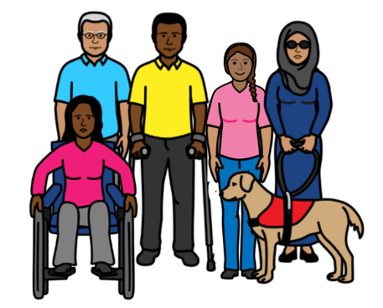
We will work with people and groups like
- people with disability
- other disability organisations
- government
- decision makers.

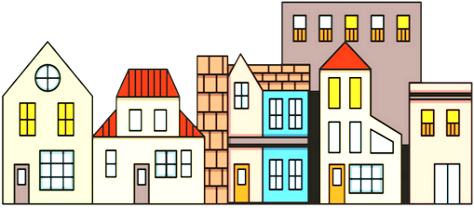
Focus area 3. Make community better.
We will make sure the community include
people with disability.

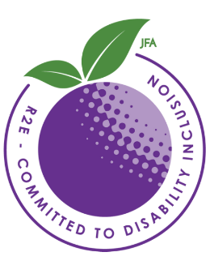
We will run projects that will make the community better. Like


- Road to Employment
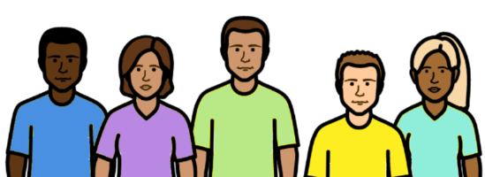
- Quality Disability Support

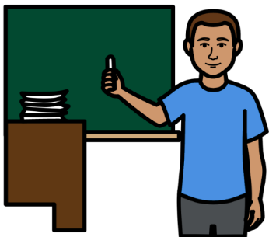
We will make new training.
Our training will be run by people with disability.

We will work with other places. like
- university
- other organisations
- decision makers

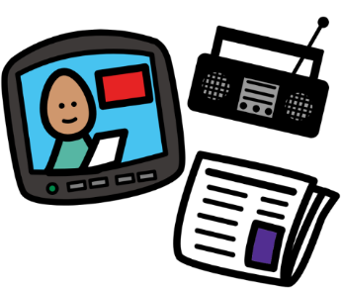
We will share the work we do. Like
- videos
- podcasts
- other content.
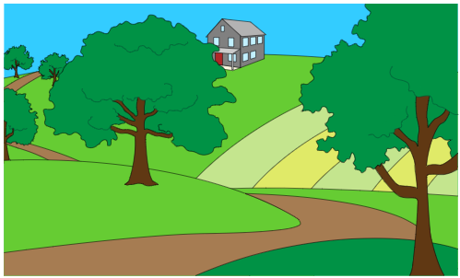
Focus area 4. Work with people in the country.
We will work with people with disability in
country areas.

We will talk to people in the country. We
- will ask questions
- will listen
- will learn.

We will use what we hear to plan our work.
We will talk about what people tell us.

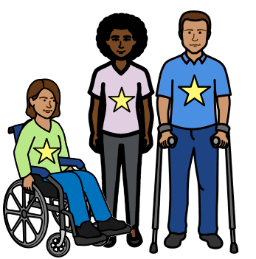
We will help people with disability be leaders in country areas.

We will share stories from the country. Like
- videos
- podcasts
- other content

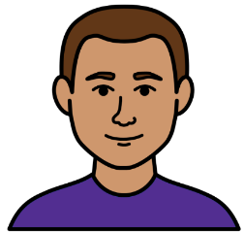
We will make sure we have workers in the country.
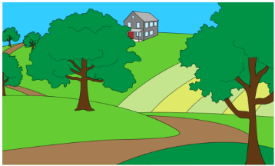
Will make sure there is money for country projects.

Focus area 5. Be a good place to work and visit.
We will change how we do things to
make them better.

Everyone is welcome at Purple Orange.
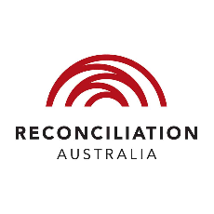
We will make new plans so we are a better place to work and visit. Like
- Disability Action Plan
- Reconciliation Action Plan.


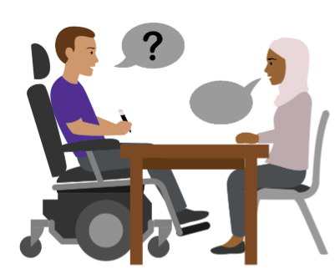
We will do things to make us a good place to work. Like
- have easy ways to get jobs
- have people with disability work at Purple Orange.

We will share information in ways people can
understand. Like
- Easy English. Like this report
- video
- pictures
- listen to it.

We will work in ways that are
- fair
- responsible
- respectful
- honest


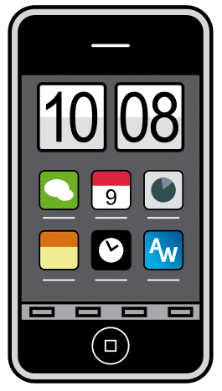
We will use new tools.
These tools will help us do better work.

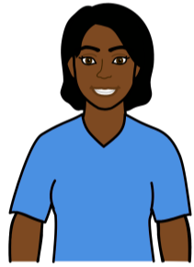
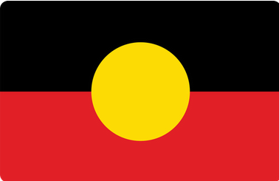
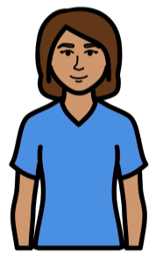
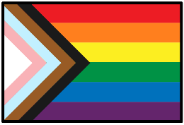
We will talk to different groups of people with disability. Like
- First Nations people
- LGBTQIA+ people
- who are from different countries.

We will use what we hear to plan our work.
We will talk about what people tell us.

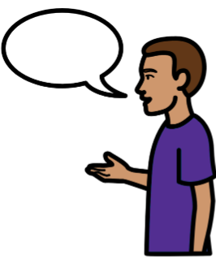
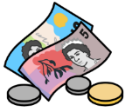
We will look for ways of making money.
We do not wan to keep asking for grant money.


Images
We can use the images from
- Tobbi-Dynavox
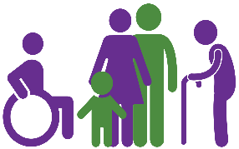
- Noun Project
- Canva
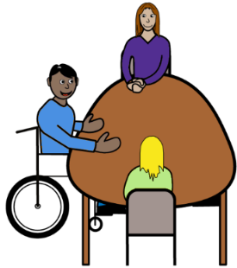
- Picto-Selector
- EasyOnTheI

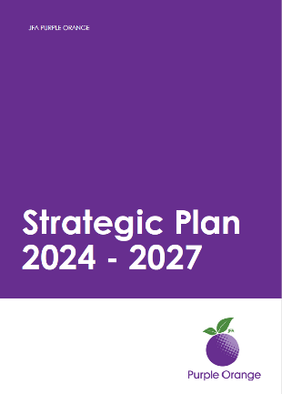
This plan is based on the
JFA Purple Orange Strategic Plan 2024 - 2027. July 2024

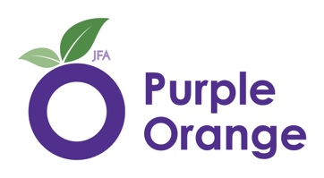

We wrote the Easy English.

